Rolling Thunder UK

We are Veterans and Civilian Supporters fighting for justice against the vexatious prosecutions of our Northern Ireland veterans like soldiers A-Z. This we are doing by organising and attending support marches and rides with other veteran and biker groups. Many of these veterans are elderly and infirm but are being subjected to intensive and aggressive interrogation.

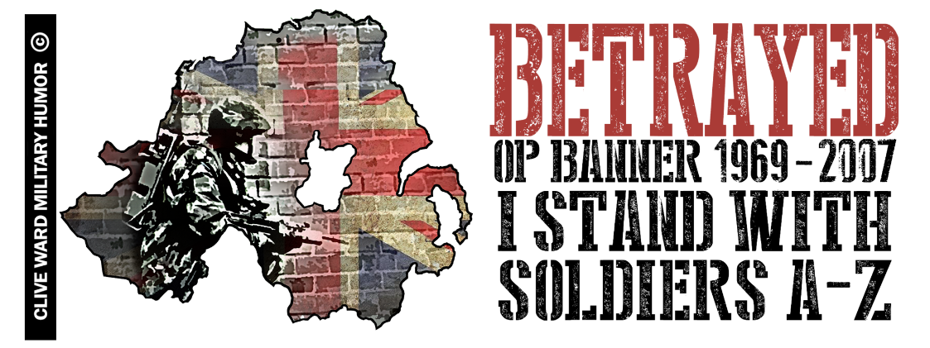
Currently there are 6 soldiers facing trials for alleged offences from over 40 years ago whilst carrying out their lawful duties, in all cases multiple investigations have cleared each soldier of any wrong doing and they were all told that was the end of it. For more information please visit our Mission page at
www.rollingthunderuk.com

Rolling Thunder UK

We are Veterans and Civilian Supporters fighting for justice against the vexatious prosecutions of our Northern Ireland veterans like soldiers A-Z. This we are doing by organising and attending support marches and rides with other veteran and biker groups. Many of these veterans are elderly and infirm but are being subjected to intensive and aggressive interrogation.

Currently there are 6 soldiers facing trials for alleged offences from over 40 years ago whilst carrying out their lawful duties, in all cases multiple investigations have cleared each soldier of any wrong doing and they were all told that was the end of it. For more information please visit our Mission page at
www.rollingthunderuk.com

